7. Write a j-Query to Attach a click and double-click event to the

element.

<!DOCTYPE html>

<html lang="en">

<head>

<meta charset="UTF-8">

<meta name="viewport" content="width=device-width, initial-scale=1.0">

<title>Click & Double Click Events</title>

<script src="https://code.jquery.com/jquery-3.6.0.min.js"></script>

<script>

$(document).ready(function() {

$('#singleClickButton').click(function() {

$('#eventResult').append('<p>This is a click event</p>');

});

$('#doubleClickButton').dblclick(function() {

$('#eventResult').append('<p>This is a Double click event</p>');

});

});

</script>

</head>

<body>

<h2>Click and Double Click Events</h2>

<!-- Buttons for click and double-click -->

<button id="singleClickButton">Single Click</button>

<button id="doubleClickButton">Double Click</button>

<div id="eventResult">

<!-- The events will append text here -->

</div>

</body>

</html>

Output:

Before

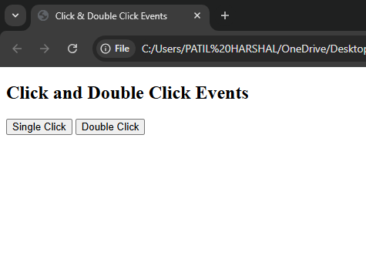

After

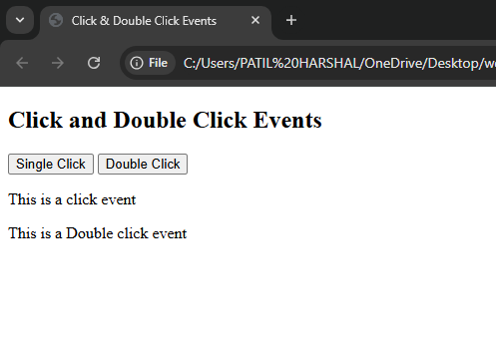

8. Write a jQuery Code to Hide all headings on a page when they are clicked.

<!DOCTYPE html>

<html>

<head>

<title>Hide Headings</title>

<script src="https://code.jquery.com/jquery-3.6.0.min.js"></script>

</head>

<body>

<h1>Heading 1</h1>

<h2>Heading 2</h2>

<h3>Heading 3</h3>

<script>

$("h1, h2, h3").click(function() {

$(this).hide();

});

</script>

</body>

</html>

Output:

Before

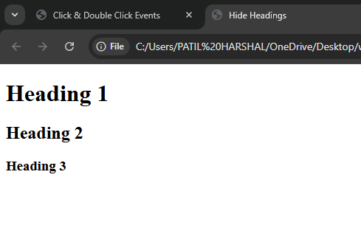

After

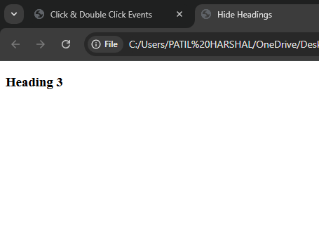

9. Write a jQuery Code to Double click on paragraph to toggle background color.

<!DOCTYPE html>

<html>

<head>

<title>Toggle Background</title>

<script src="https://code.jquery.com/jquery-3.6.0.min.js"></script>

<style>

.bg-toggle {

background-color: aqua;

}

</style>

</head>

<body>

<p>Double-click me to toggle background color!</p>

<script>

$("p").dblclick(function() {

$(this).toggleClass("bg-toggle");

});

</script>

</body>

</html>

Output:

Before

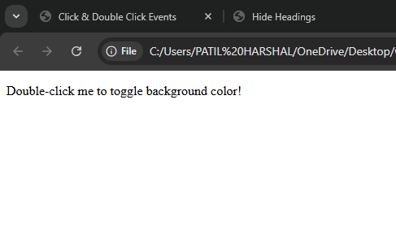

After

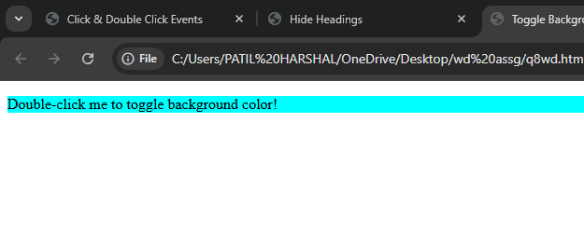

10. Write a jQuery Code to Click a header to add another.

<!DOCTYPE html>

<html>

<head>

<title>Add Header</title>

<script src="https://code.jquery.com/jquery-3.6.0.min.js"></script>

</head>

<body>

<h1>Click to add another header:</h1>

<script>

$("h1").click(function() {

$(this).after("<h2>PATIL HARSHAL</h2>");

});

</script>

</body>

</html>

Output:

Before

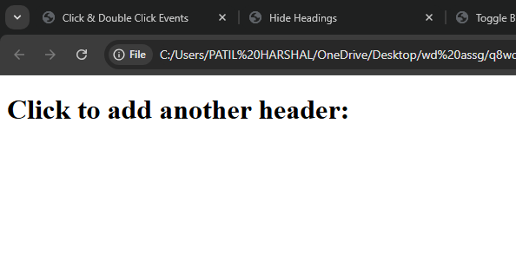

After

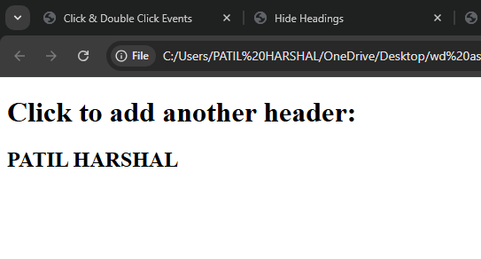

11. Write a jQuery Code to Find the data passed with the on() method for each

element.

<!DOCTYPE html>

<html>

<head>

<title>Find Data</title>

<script src="https://code.jquery.com/jquery-3.6.0.min.js"></script>

</head>

<body>

<p>Click to see the data passed:</p>

<script>

$("p").on("click", {info: "hello madam💕"}, function(event) {

alert("Data passed: " + event.data.info);

});

</script>

</body>

</html>

Output:

Before

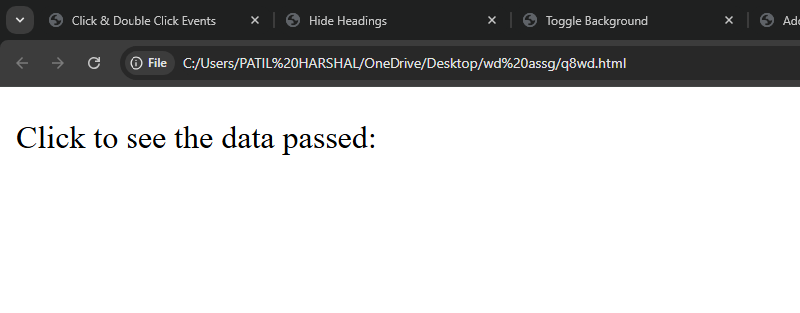

After

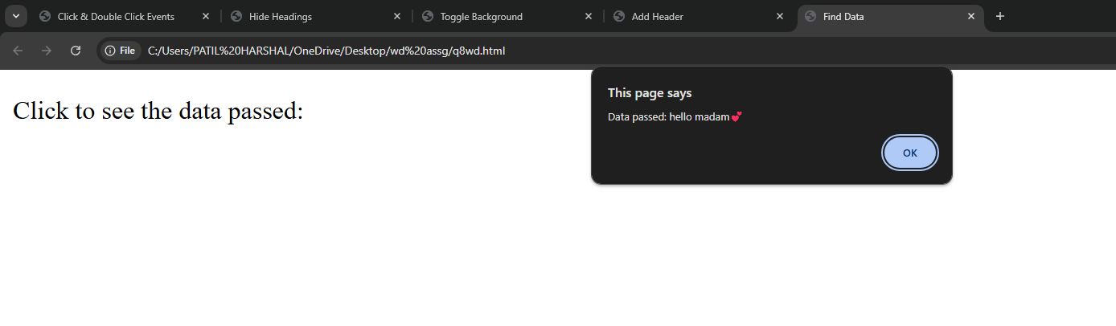

12. Write a jQuery Code to Change the background color of the element of the following code on clicking the button.

<!DOCTYPE html>

<html>

<head>

<title>Change Div Background</title>

<script src="https://code.jquery.com/jquery-3.6.0.min.js"></script>

</head>

<body>

<div style="border: 1px solid black; padding: 10px;">Click the button to change

background color</div>

<button>Change Background</button>

<script>

$("button").click(function() {

$("div").css("background-color", "red");

});

</script>

</body>

</html>

Output:

Before

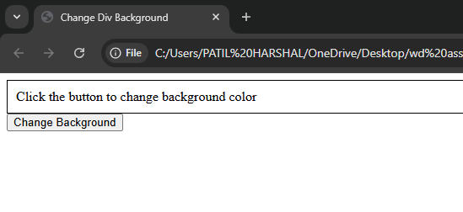

After

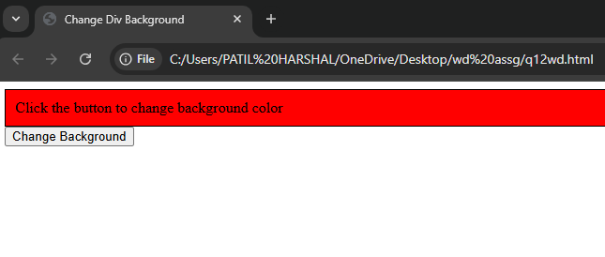

13. Write a jQuery Code to Cancel the default action (click) of the first URL.

<!DOCTYPE html>

<html>

<head>

<title>Prevent Default Action</title>

<script src="https://code.jquery.com/jquery-3.6.0.min.js"></script>

</head>

<body>

<a href="https://example.com" id="my-link">Click:(default action prevented)</a>

<script>

$("#my-link").click(function(event) {

event.preventDefault();

alert("Default action prevented!");

});

</script>

</body>

</html>

Output:

Before

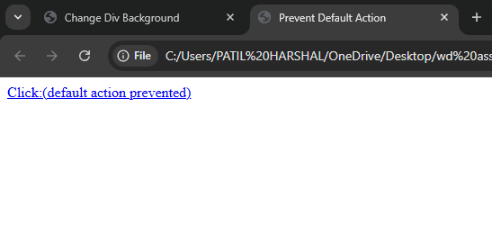

After

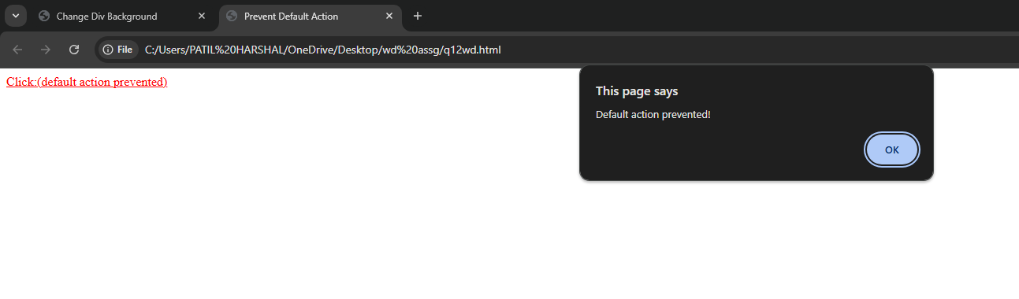

14. Write a jQuery Code to Display the tag's name on click.

<!DOCTYPE html>

<html>

<head>

<title>Display Tag Name</title>

<script src="https://code.jquery.com/jquery-3.6.0.min.js"></script>

</head>

<body>

<p>Click to see my tag name</p>

<script>

$("p").click(function() {

alert("Tag name: " + $(this).prop("tagName"));

});

</script>

</body>

</html>

Output:

Before

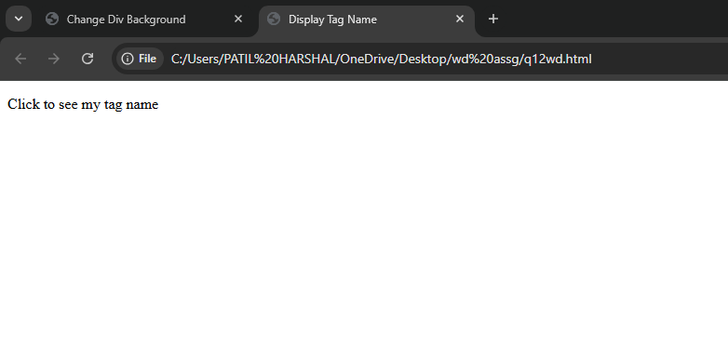

After

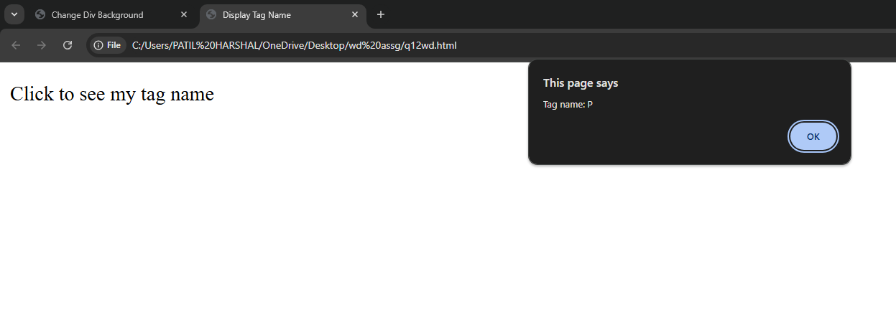

15. Write a jQuery Code to Display the keyboard key which was pressed in a textbox.

<!DOCTYPE html>

<html>

<head>

<title>Keyboard Key Press</title>

<script src="https://code.jquery.com/jquery-3.6.0.min.js"></script>

</head>

<body>

<input type="text" id="key-input" placeholder="Type something">

<p id="output"></p>

<script>

$("#key-input").keypress(function(event) {

$("#output").text("Key pressed: " + event.key);

});

</script>

</body>

</html>

Output:

Before

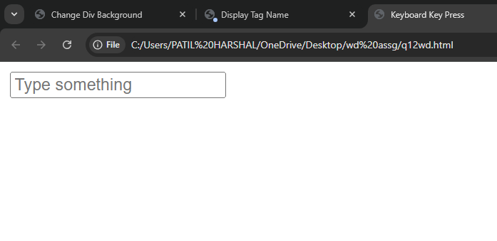

After

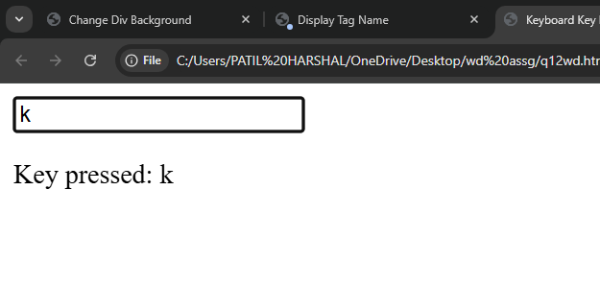

16. Write a jQuery Code to Attach a function to the focus event. The focus event occurs (display a message regarding the text field) when the field gets focus.

<!DOCTYPE html>

<html>

<head>

<title>Focus Event</title>

<script src="https://code.jquery.com/jquery-3.6.0.min.js"></script>

</head>

<body>

<input type="text" id="focus-input" placeholder="Focus">

<p id="message"></p>

<script>

$("#focus-input").focus(function() {

$("#message").text("The input field is focused");

});

</script>

</body>

</html>

Output:

Before

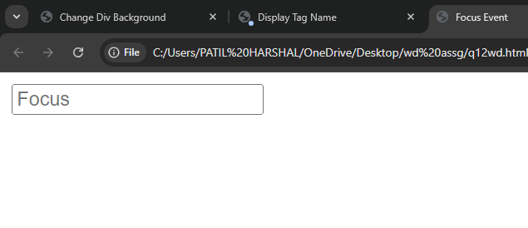

After

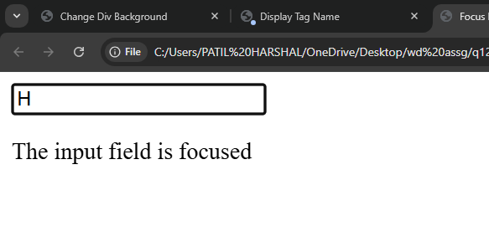

17. Write a jQuery Code to Set background color of an element when the element (or any elements inside it) gets focus or loses focus.

<!DOCTYPE html>

<html>

<head>

<title>Focus and Blur</title>

<script src="https://code.jquery.com/jquery-3.6.0.min.js"></script>

</head>

<body>

<div tabindex="0" id="focus-box" style="border: 1px solid black; padding: 20px;">

Click inside this box to see the focus effect.

</div>

<script>

$("#focus-box").on("focus blur", function(event) {

if (event.type === "focus") {

$(this).css("background-color", "lightgreen");

} else {

$(this).css("background-color", "");

}

});

</script>

</body>

</html>

Output:

Before

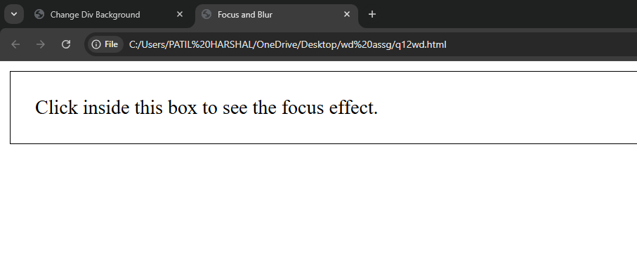

After

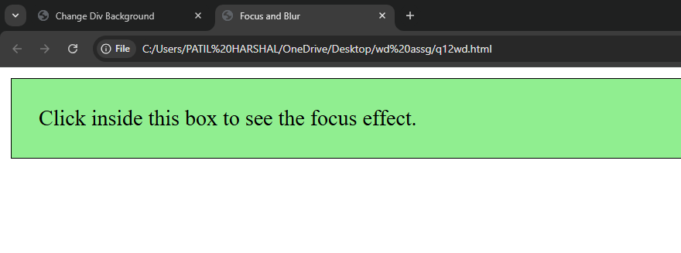

18. Write a jQuery Code to Count the number of specific elements.

<!DOCTYPE html>

<html>

<head>

<title>Count Specific Elements</title>

<!-- Import jQuery -->

<script src="https://code.jquery.com/jquery-3.6.0.min.js"></script>

</head>

<body>

<h1>Count Specific Elements</h1>

<!-- Elements to count -->

<div class="specific">Element 1</div>

<div class="specific">Element 2</div>

<div class="specific">Element 3</div>

<div>Other Element</div>

<!-- Button to trigger counting -->

<button id="countButton">Count Specific Elements</button>

<!-- Area to display result -->

<p id="result"></p>

<script>

$(document).ready(function () {

$("#countButton").click(function () {

let count = $(".specific").length;

$("#result").text("Number of specific elements: " + count);

});

});

</script>

</body>

</html>

Output:

Before

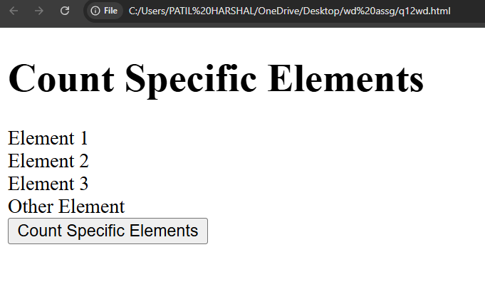

After

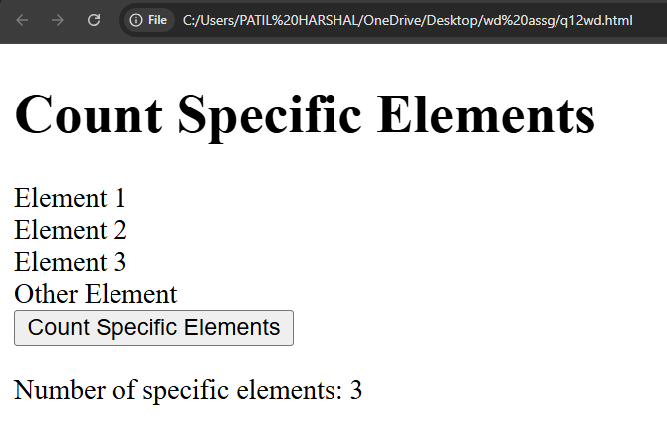

19. Write a jQuery Code to Show texts when mouseup and mousedown event triggering.

<!DOCTYPE html>

<html>

<head>

<title>Mouse Events</title>

<!-- Import jQuery -->

<script src="https://code.jquery.com/jquery-3.6.0.min.js"></script>

</head>

<body>

<h1>Mouse Events</h1>

<!-- Button for triggering events -->

<button id="eventButton">Click</button>

<!-- Area to display event messages -->

<p id="message"></p>

<script>

$(document).ready(function () {

$("#eventButton").mousedown(function () {

$("#message").text("Mouse button is pressed");

});

$("#eventButton").mouseup(function () {

$("#message").text("Mouse button is released");

});

});

</script>

</body>

</html>

Output:

Before

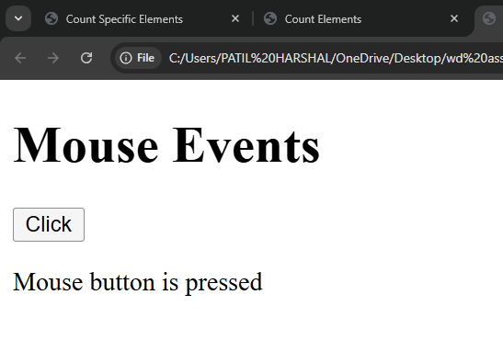

After

